**Social Media Marketing**

**Week 6: Complete Campaign and**

**Strategy Project.**

**Submitted by: Iqra Tariq**

**Objective: Design a full social media marketing campaign with paid and organic content.**

**Task 1:** Choose a product/service/niche and create a **14-day content plan** with post types, captions and hashtags.

**14-Day Fitness Content Plan**

**Day 1: Motivation Monday (Quote Post)**

* Post Type: Carousel or Reels with inspiring fitness quote.
* Caption:  
  *“The only bad workout is the one that didn’t happen. Start your week strong. Let’s crush it together!”*
* Hashtags:  
  #MondayMotivation #FitnessMindset #NoExcuses #FitLife #FitnessGoals

**Day 2: Transformation Tuesday (Client or Personal Progress)**

* Post Type: Before/after photos or testimonial.
* Caption:  
  *“Transformation isn’t just physical—it’s mental and emotional too. Swipe to see what consistent work can do. Ready for your glow-up?”*
* Hashtags:  
  #TransformationTuesday #FitnessJourney #FatLoss #BodyGoals #OnlineCoach

**Day 3: Workout Wednesday (Follow-Along Routine)**

* Post Type: Reels or carousel workout (3–5 exercises).
* Caption:  
  *“FULL BODY BURN   
  Try this 15-min workout—no equipment needed.  
  ✅ Save & share with a workout buddy!”*
* Hashtags:  
  #WorkoutWednesday #HomeWorkout #QuickWorkout #NoExcuses #TrainHard

**Day 4: Tip Thursday (Educational Carousel)**

* Post Type: Carousel post with tips (e.g., “5 ways to boost fat loss”).
* Caption:  
  *“Swipe to learn 5 science-backed fat loss tips most people ignore.”*
* Hashtags:  
  #FitnessTips #FatLossTips #FitnessEducation #HealthHack #FitFacts

**Day 5: Feature Friday (Client Shoutout or Collab)**

* Post Type: Image or short video testimonial.
* Caption:  
  *“Meet [Client Name]—down 15 lbs. and up in confidence. Consistency wins every time!”*
* Hashtags:  
  #ClientSpotlight #FitnessCoach #OnlineTrainer #FitnessSuccess #FridayFeature

**Day 6: Saturday Sweat (Challenge or Live Invite)**

* Post Type: Reels or story promo.
* Caption:  
  *“Join me LIVE at 9am for a 20-min HIIT blast. Let’s sweat together. Who’s in?”*
* Hashtags:  
  #SaturdaySweat #LiveWorkout #GroupFitness #SweatSession #FitnessChallenge

**Day 7: Sunday Self-Care (Recovery or Mindset Post)**

* Post Type: Image of a recovery activity (stretching, nature, meal).
* Caption:  
  *“Recovery is just as important as training. Rest, hydrate, stretch—your body will thank you. ”*
* Hashtags:  
  #SelfCareSunday #RecoveryDay #RestAndRecover #FitnessBalance #HealthyHabits

**Day 8: Myth-Busting Monday**

* Post Type: Carousel or Reels busting a common fitness myth.
* Caption:  
  *“MYTH: Lifting weights makes you bulky.  
  FACT: Lifting builds lean muscle, speeds up metabolism, and tones your body. Let’s lift smart ”*
* Hashtags:  
  #FitnessMyths #LiftHeavy #StrengthTraining #LeanMuscle #WomenWhoLift

**Day 9: Testimonial Tuesday**

* Post Type: Video or quote testimonial.
* Caption:  
  *“‘I’ve never felt more confident in my body.’ — [Client Name]   
  Real results. Real people. DM to start yours.”*
* Hashtags:  
  #TestimonialTuesday #FitnessResults #HappyClients #FitnessCoach #OnlinePrograms

**Day 10: Workout Wednesday (Gym Edition)**

* Post Type: Gym workout routine.
* Caption:  
  *“Upper Body Day   
  ✅ Shoulder Press  
  ✅ Lat Pulldown  
  ✅ Rows  
  ✅ Face Pulls  
  Tag your workout partner and try this!”*
* Hashtags:  
  #GymWorkout #PushDay #UpperBodyWorkout #StrengthTraining #WorkoutRoutine

**Day 11: Q&A Thursday (Interactive Story or Reels)**

* Post Type: Reels answering FAQs.
* Caption:  
  *“Q: Should I train every day?  
  A: No! Your body needs recovery to grow. Swipe for a weekly workout split.”*
* Hashtags:  
  #FitnessQuestions #FitnessQandA #AskYourCoach #TrainingSplit #RecoveryMatters

**Day 12: Fun Friday (Behind-the-Scenes / Trainer Life)**

* Post Type: BTS video or daily vlog style.
* Caption:  
  *“Come with me on a day in the life of a fitness coach Coffee, clients, cardio & chaos”*
* Hashtags:  
  #FitLife #TrainerLife #FitnessCoach #FitnessBTS #FitnessVibes

**Day 13: Client Win Saturday**

* Post Type: Photo or chart of progress.
* Caption:  
  *“Another win! [Client Name] dropped 4 inches off the waist in 6 weeks. That’s what consistent coaching + mindset does.”*
* Hashtags:  
  #ClientResults #FitnessWin #ProgressNotPerfection #BodyRecomposition #OnlineCoaching

**Day 14: Sunday Reflection (Mindset Post)**

* Post Type: Image with reflective quote.
* Caption:  
  *“Fitness is a lifelong journey, not a quick fix. What did you learn this week?”  
  Reflect, reset, and get ready to crush next week.”*
* Hashtags:  
  #MindsetMatters #FitnessJourney #SundayReflections #HealthyMind #WeeklyReset

**Task 2:** Design **5 creative posts** (images, carousel, reels ideas) with captions.

**POST 1: Image Post – Motivational Quote**

**Caption:**

“You won’t *always* feel motivated.  
But if you stay disciplined, you’ll always move forward.”

#DisciplineOverMotivation #FitnessMindset #NoExcuses #StayHungry #FitLife

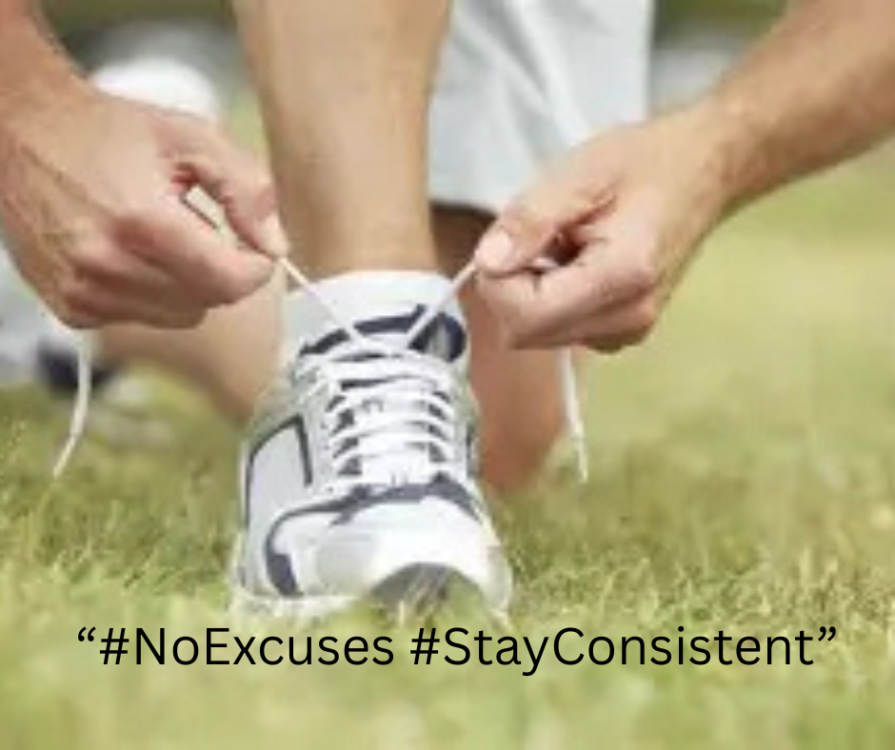

**POST 2: Carousel Post – “5 Fat Loss Exercises”**

**Caption:**

“Let’s fix the fat loss frustration.  
Do 5 fat loss exercises and watch your body (and mindset) change fast.”  
#FatLossTips #FitnessEducation #WeightLossHelp #FitForLife #FitnessFacts

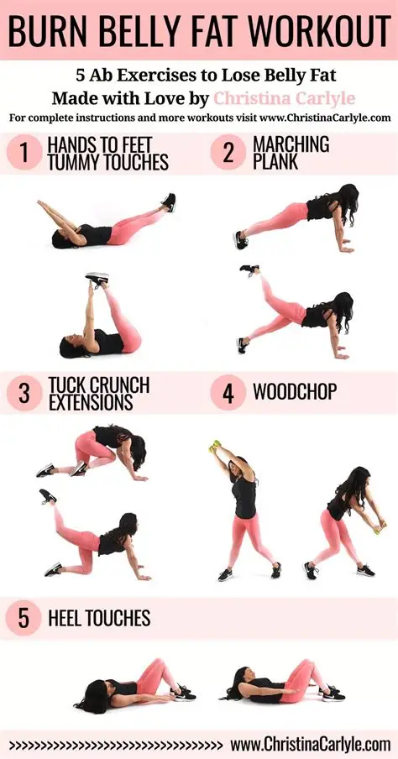

**POST 3: Reel – “3 No-Equipment Leg Burner Moves”**

**Caption:**

“No gym? No problem.  
Here’s your go-to LEG DAY Try this 3-move circuit from anywhere!  
#HomeWorkout #LegDayEveryday #BodyweightWorkout #HIITLegs #NoGymNoExcuse

[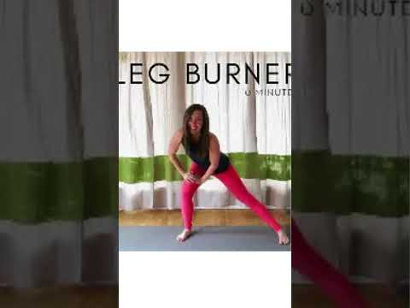](https://www.youtube.com/embed/6bA2x0HuIyM?feature=oembed)

**POST 4: Carousel – “What I Eat in a Day (Fat Loss Edition)”**

**Caption:**

“Fat loss isn’t about starving.  
It’s about smart fuel. Here’s a peek into a 1800-cal day I use for myself and my clients.  
Want your own custom meal guide? DM me ‘MEAL’”  
#WhatIEatInADay #FatLossMeals #MacroFriendly #HealthyEating #FitnessFuel

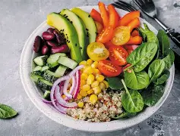**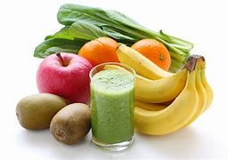POST 5: Reel – Day in the Life of a Fitness Coach**

**Caption:**

“From coaching calls to workouts to meal prep...  
Here’s a quick look at a day in my life as a fitness coach.  
Real talk: it’s not always pretty—but it’s always worth it.”  
#DayInTheLife #FitnessCoachLife #OnlineTrainer #FitLifeVlog #BehindTheScenes

[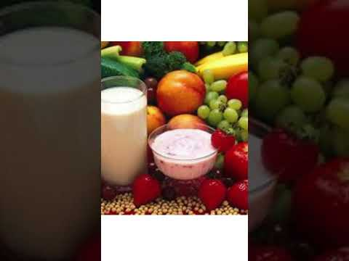](https://www.youtube.com/embed/VKRiSyBqrcc?feature=oembed)

**Task 3:** Draft a **mock paid ad campaign plan** (budget, audience, ad content, duration).

**PAID AD CAMPAIGN PLAN – “Get Fit in 30 Days Challenge”**

**✅ Campaign Objective**

Lead Generation – Collect emails or DMs to join a free 30-day fitness challenge, designed to convert leads into long-term clients**.**

**💰 Budget**

| **Type** | **Amount** |
| --- | --- |
| Total Budget | Rs 30000 (Test Campaign) |
| Daily Spend | 100/day |
| Duration | 30 Days |
| Platform | Meta Ads (Facebook + Instagram) |

**🎯 Target Audience**

**Location:** Pakistan, Canada, UK, Australia **Age:** 24–45 **Gender:** All

**Interests:**

* Fitness & Wellness
* Weight Loss
* Gym Life
* Home Workouts
* MyFitnessPal, Fitbit, Peloton
* Joe Wicks, Kayla Itsines, or similar influencers

**Behaviors:**

* Engages with fitness content
* Recently interacted with fitness ads
* Uses fitness apps

**Custom Audiences:**

* Website visitors (last 90 days)
* Instagram/Facebook engagers
* Email subscribers (retargeting)

**📢 Ad Content (Creative & Copy)**

**1. Video Ad (Reels & Stories Optimized)**

**Visual:** Fast-paced 15s clip of:

* Workout snippets
* Client transformations
* **Text overlay:** *“Join the FREE 30-Day Fitness Challenge”*

**Caption:**

“You’re ONE decision away from your best self.   
Join my FREE 30-Day Challenge and transform your body at home or in the gym.  
No equipment? No problem.  
Daily workouts  
Easy meal tips  
 Support + accountability  
Click Sign Up and let's go!”

CTA: "Sign Up" or "Send Message"

**2. Static Image Ad (News Feed & Stories)**

**Image:** Split image of before/after + bold header:  
*“Get Fit in 30 Days – Free Challenge Starts Now”*

Caption:

“Tired of starting over every Monday?  
Let me coach you for 30 days—for FREE.  
 Burn fat  
 Build confidence  
 Eat better  
Join hundreds who’ve transformed with my system. Tap below to start now!”

CTA: "Learn More"

**📊 Landing Page or Lead Magnet**

* **Option A:** Simple lead page to collect email/name for follow-up sequence.
* **Option B**: Direct to IG DMs with automation (Many Chats, DM “CHALLENGE” to enter).

**📈 Success Metrics (KPIs)**

| **Metric** | **Goal** |
| --- | --- |
| CPL (Cost per Lead) | <Rs.100 |
| Leads Generated | 100+ |
| Click-Through Rate | >2% |
| Ad Frequency | <3 (avoid fatigue) |
| Conversion Rate | >10% on email follow-up |

**🔁 Retargeting Strategy (Week 3–4)**

* Retarget ad viewers and engagers with testimonials or urgency-based ads:

“Spots closing soon – Don’t miss the next round of the 30-Day Challenge!”

**Task 4:** Create a **post-campaign performance reporting format.**

**🧾 POST-CAMPAIGN PERFORMANCE REPORT**

**Campaign Title:** *30-Day Fitness Challenge Lead Gen* **Platform(s):** Facebook + Instagram **Duration:** 15-07-2025 – 15-08-2025 **Total Budget:** Rs. 50000

**1. Executive Summary**

* Objective: [e.g. Generate leads for a free challenge, increase brand awareness]
* Result: [Short summary, e.g. "We generated 112 leads at an average cost of Rs.500 per lead. CTR was strong at 2.8%, indicating high relevance."]

**📈 2. Key Performance Metrics**

| **Metric** | **Target/Goal** | **Actual Result** | **Notes** |
| --- | --- | --- | --- |
| Impressions | [e.g. 50,000] | [XX, XXX] | - |
| Reach | [e.g. 30,000] | [XX, XXX] | - |
| Click-Through Rate (CTR) | >2% | [X.XX%] | Good/Needs improvement |
| Link Clicks | [e.g. 1,500] | [XXX] | - |
| Leads Generated | [e.g. 100+] | [XXX] | - |
| Cost Per Lead (CPL) | <100 | $[X.XX] | Efficient/High |
| Engagement (likes/comments) | [XX] | [XXX] | - |
| Video Views (if applicable) | [XX, XXX] | [XX, XXX] | 3s/15s completions |
| Conversion Rate | [e.g. 10%] | [XX%] | Leads → Signups |
| Ad Frequency | <3 | [X.X] | Watch for ad fatigue |

**🎯 3. Audience Insights**

| **Demographic** | **Top Performing Segment** |
| --- | --- |
| Gender | Women 25–34 |
| Location | Pakistan, UK |
| Devices | Mobile > Desktop |
| Interests | Weight loss, home workouts |

**🖼️ 4. Creative Performance Breakdown**

| **Ad Creative** | **Format** | **CTR** | **CPL** | **Notes** |
| --- | --- | --- | --- | --- |
| Video Ad #1 | Reels | 3.2% | Rs.800 | Strong visuals, high click-through |
| Static Image Ad | Feed | 1.8% | Rs.550 | Lower engagement |
| Carousel Ad | Feed | 2.5% | Rs.650 | Good performance overall |

**🔁 5. Retargeting Campaign Results (if applicable)**

| **Metric** | **Result** | | **Notes** | |
| --- | --- | --- | --- | --- |
| Impressions | [XX, XXX] | |  | |
| CTR | [X.XX%] | |  | |
| CPL | Rs. [X.XX] | |  | |
| ROAS (if selling) | | [X.X] | |  |